Short Stop (SS) Infield Plans

This is a practice that can be done on the field as well as off. The goal is to obtain mental readiness so the player can execute their plan without thinking during execution. Overall concept is:
Control – Am I in my ready position? Glove on, standing in right area…
Plan – What’s my play if I get the ball; plan the play before it happens, have a backup plan; if I drop the ball then what?
Trust – Trust! Trust that you will execute your plan because you’ve already gone over it in your head.

Mental Checklist
- Control: Am I in my ready position?
- Plan: If I get the ball. SS base strategies, you are the cutoff person for the left side of the outfield, if the ball goes out there you must be facing them to receive it.
NOTE: If I see the ball going to the 2nd base person, I go to 2nd base.
RUNNERS ON | PLAN | BACKUP PLAN
None | Throw to 1st base. | Lob ball to 2nd base person who will be at 2nd base.
1st | In most cases throw to 1B base. Ball hit up the middle, touch 2nd base or throw/soft toss to 2B, otherwise go 1B. | Look for oncoming runner to tag, else get it back to pitcher.
1st, 2nd | In most cases throw to 1B base. Ball hit up the middle, touch 2nd base or throw/soft toss to 2B, otherwise go 1B. Ball hit towards 3B, soft toss to 3B, otherwise got 1B. | Possible throw to home depending on if runners continue else get it back to the pitcher.
1st, 2nd, 3rd | In most cases throw to 1B base.  Ball hit up the middle, throw or soft toss to 2B, otherwise go 1B. Ball hit towards 3B, soft toss to 3B, otherwise got 1B. | Possible throw to home depending on if runners continue else get it back to the pitcher.
2nd | Throw to 1B. | Get it back to pitcher.
2nd, 3rd | Throw to 1B. Only consider throwing home if it’s a close game and in the final innings. Force outs are most important. | Get it back to pitcher.
1st, 3rd | In most cases throw to 1B base. Ball hit up the middle, touch 2nd base or throw/soft toss to 2B, otherwise go 1B. | Get it back to pitcher.

- Trust!

Mastering the easy outs is a good place to start since they take less strategy. Planning the play can be done on the field and off. As a mental exercise, you can run through plays with your child in the car, on the way home from school or at home for a few minutes. The more mental repetitions they have of thinking the play the chances are higher they will execute the play without thinking once presented with the situation.
Runner Stealing
Only when a runner is on 1st base will we cover second for a throw down from the catcher to get a tag out.
- For a LEFT hand batter, if the ball is not hit, run to the back side of second base to cover a throw from the catcher. You don’t want this guy stealing on you.
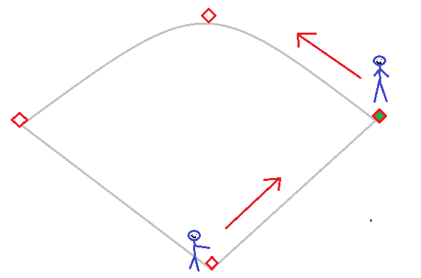
Pick Off
If runners are in either of the follow pictures AND it’s a LEFT hand batter, creep behind 2nd base in case the pitcher decides to throw back to 2nd. If the pitcher moves forward into a pitch run back to your normal position fast, at this point the pitcher must finish the pitch and you don’t want to miss a hit ball.
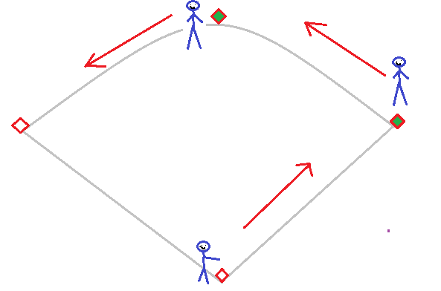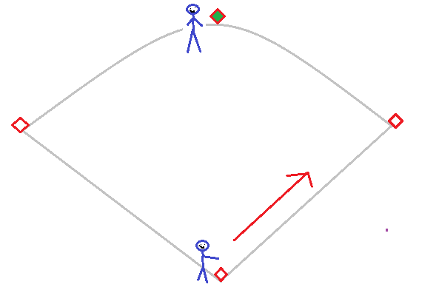

Bunts
On a bunt, you will cover 3rd base for the 3rd basemen because he will move up to cover the bunt.

